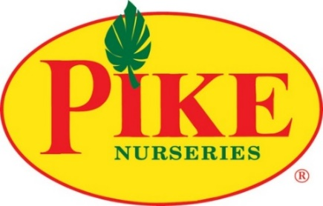

**For More Information:**

Brianna Poplaskie/ Caroline Day

BRAVE Public Relations

404.233.3993

[bpoplaskie@emailbrave.com](mailto:bpoplaskie@emailbrave.com)/  
[cday@emailbrave.com](mailto:cday@emailbrave.com)

**\*\*MEDIA ADVISORY\*\***

**Pike Nurseries seeking to hire over 170 team members this fall**

*Southeast’s largest independent garden retailer grows with career opportunities*

**ATLANTA (Aug. 22, 2024)** –As the fall season approaches and the holidays linger around the corner, **Pike Nurseries** is seeking approximately **170** employees across all Atlanta-area locations. As the cooler air settles, gardeners are getting back in their yards to take advantage of the warm soil and mild temperatures that make fall the perfect time to plant. Pike Nurseries is looking for enthusiastic team members now through the Christmas season to join their workforce of employee-owners dedicated to providing quality customer service.

The garden retailer’s available positions include cashiers, loading personnel and sales associates, and responsibilities include providing exceptional service to customers, watering, preparing and loading plants and Christmas trees. Gardeners and professionals of all skill levels are encouraged to apply, from seasoned experts to first-time employees. Applicants should enjoy people and plants, as well as working in an active, friendly outdoor environment. Horticultural knowledge is a plus but not required for all positions. Pike Nurseries offers flexible hours ideal for those with irregular schedules.

To explore open positions and submit an application any time, please visit [pikenursery.com/careers](https://www.pikenursery.com/about-us/careers).

**WHAT:** **Pike Nurseries Fall Job Opportunities - Full-Time & Seasonal**

*Available positions include manager trainees, cashiers, sales associates and loading personnel*

**WHERE:** **Positions available at all Atlanta-area Pike Nurseries locations**

Please visit [pikenursery.com](http://www.pikenursery.com/locations) for local store information.

**HOW:** Interested candidates are encouraged to explore job opportunities and apply in person at their local Pike Nurseries store or online at [pikenursery.com/careers](https://www.pikenursery.com/about-us/careers).

###